### 

**1.0 Logging In to the Web Portal** **4**

**2.0 Dashboard** **5**

2.1 View Dashboard 5

2.2 Statistics 6

2.2.1 Route Overview 6

2.2.2 Usage of Application 7

2.2.3 Route Details 8

**3.0 Managing Beacons** **9**

3.1 View Beacons 9

3.1.1 Toggle Beacon Status 9

3.2 Adding a Beacon 10

3.3 Updating a Beacon 11

3.4 Deleting a Beacon 12

**4.0 Managing Beacon Directions** **13**

4.1 View Beacon Directions 13

4.2 Adding a Beacon Direction 14

4.3 Updating a Beacon Direction 15

4.4 Deleting a Beacon Direction 16

**5.0 Managing Beacon Relations** **17**

5.1 View Beacon Relations 17

5.2 Adding a Beacon Relation 18

5.3 Updating a Beacon Relation 19

5.4 Deleting a Beacon Relation 20

**6.0 Managing Units** **21**

6.1 View Units 21

6.2 Adding a Unit 22

6.3 Updating a Unit 23

6.4 Deleting a Unit 24

**7.0 Managing Facilities** **25**

7.1 View Facilities 25

7.2 Adding a Facility 26

7.3 Updating a Facility 27

7.4 Deleting a Facility 28

**8.0 Managing Users** **29**

8.1 View Users 29

8.2 Adding a User 30

8.3 Updating a User 31

### 

### **1.0 Logging In to the Web Portal**

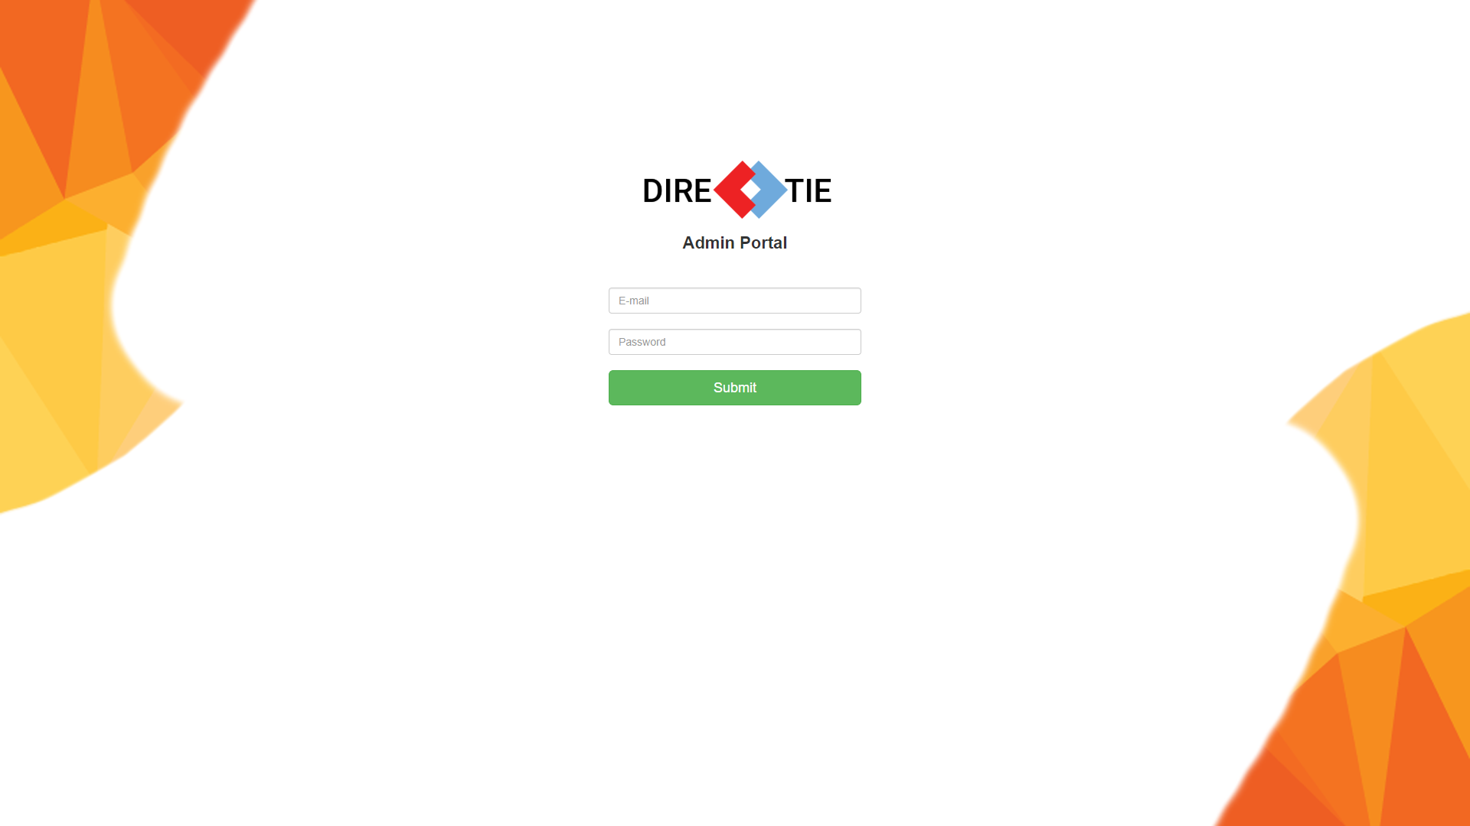

*Figure 1 Login Screen*

Enter your admin account’s credentials and click on the “Login” button below. If the credentials you have entered are correct, you will be logged in successfully into the admin portal.

Required Credentials

* Email
* Password

### **2.0 Dashboard**

#### **2.1 View Dashboard**

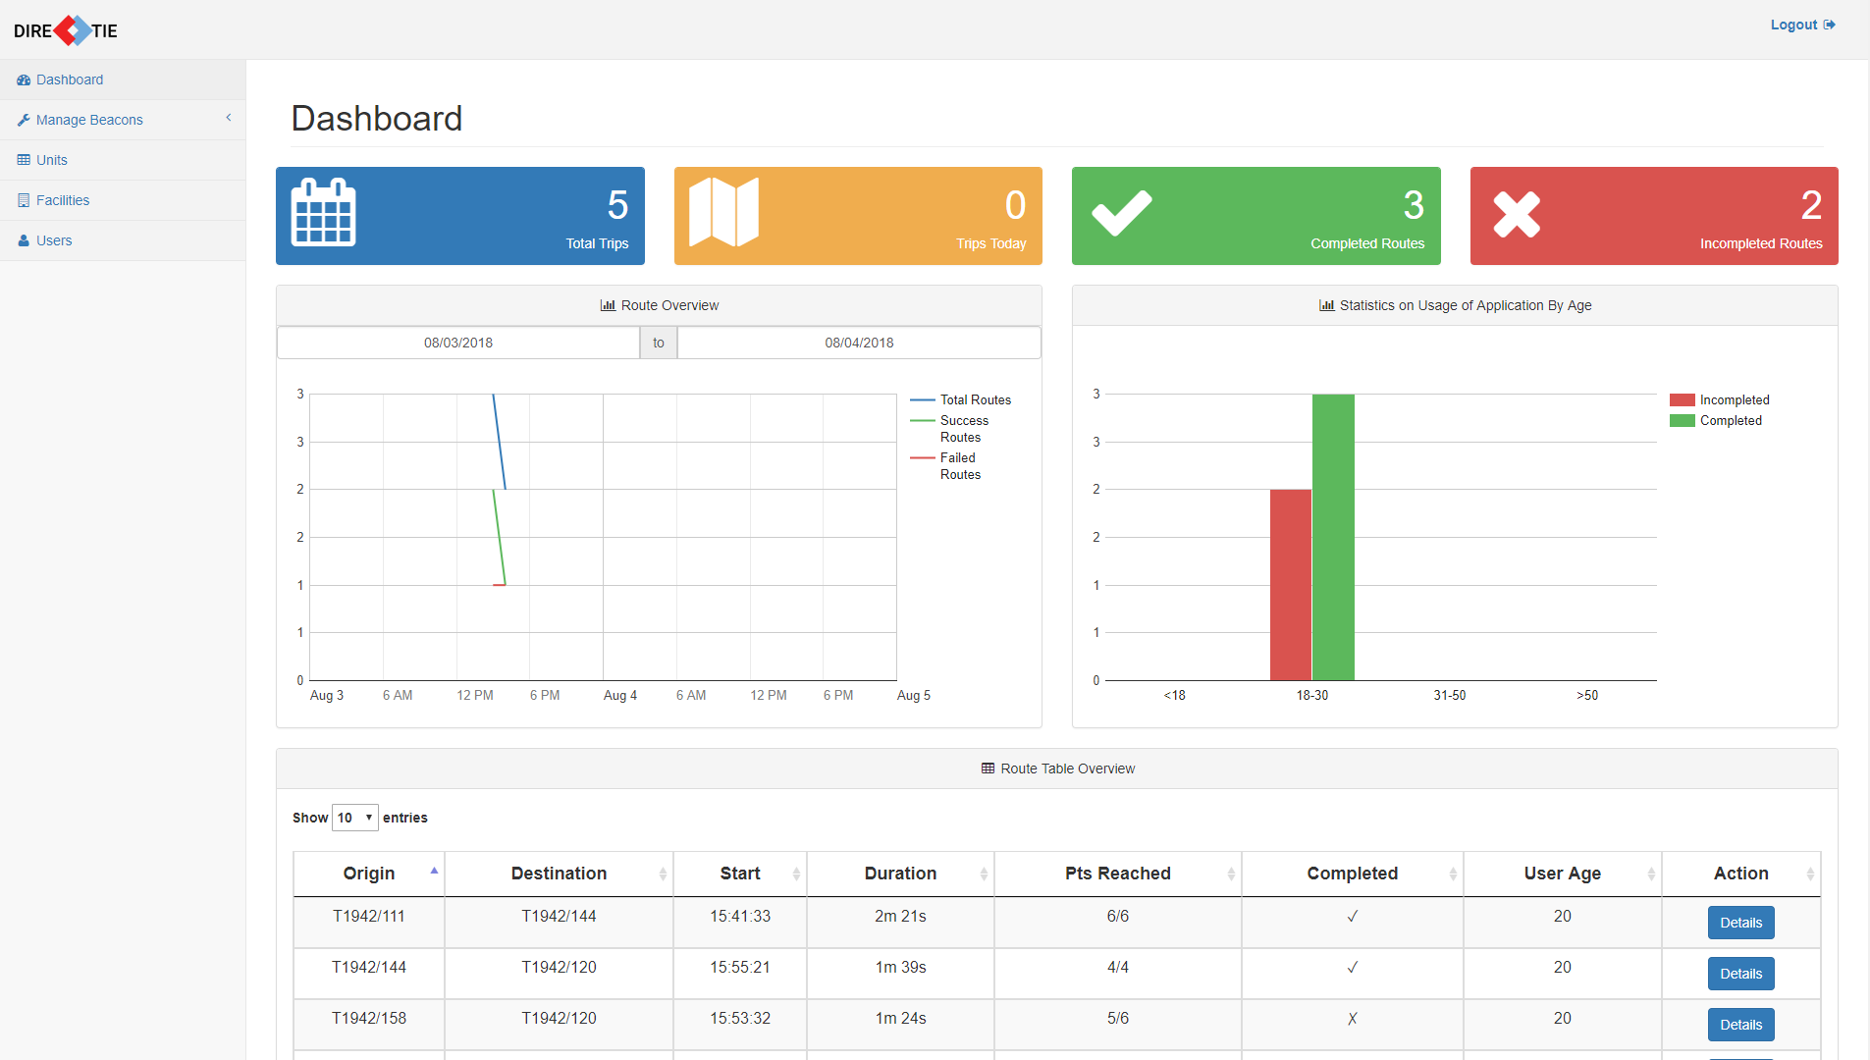

*Figure 2 Dashboard Page*

You will be brought to this page automatically after logging in. You can also reach this page by clicking on **“Dashboard”** in the navigation menu at the side when you are logged in.

On top of the page, you can see the number of routes walked, number of routes that are walked today, completed routes and failed routes

In the dashboard, you can see 2 different charts and 1 table. The date of the charts/tables can be controlled by selecting the date range under “Route Overview”.

#### **2.2 Statistics**

##### **2.2.1 Route Overview**

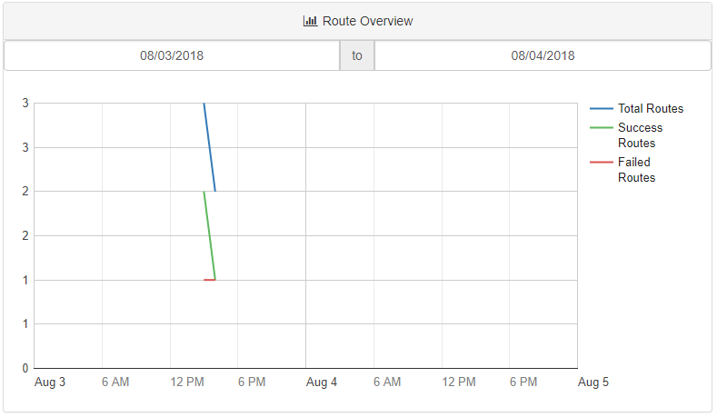

*Figure 3 Route Overview Chart*

The chart “Route Overview” as seen above in Figure 3, represents the number of total routes, success routes and failed routes for that range of date.

##### 

##### **2.2.2 Usage of Application**

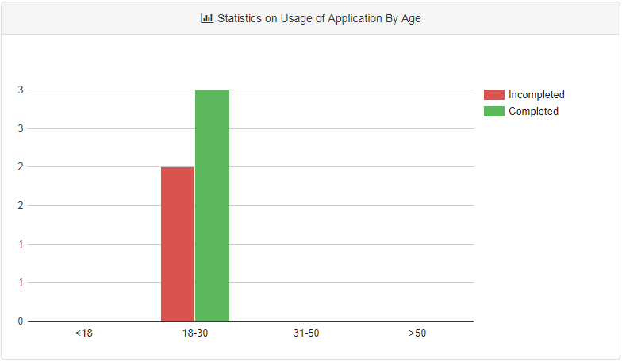

*Figure 4 Application Usage by Age Chart*

The second chart as seen above in Figure 4 shows the the usage of application by age groups for that range of date and if they managed to complete the route.

##### **2.2.3 Route Details**

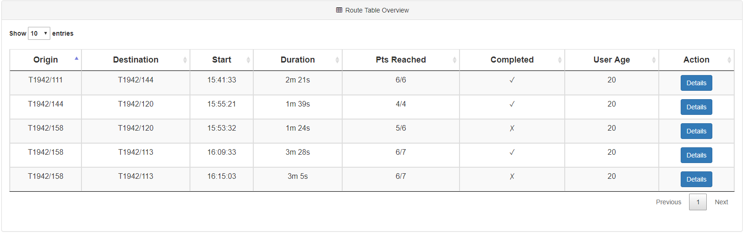

*Figure 5 Route Overview Table*

The table as seen above in Figure 5 shows every route information that is selected by the range of date. From there you can see the details such as the Origin, Destination, Start time, Duration, No. of beacons that they have passed through, Route Completion and the User Age.

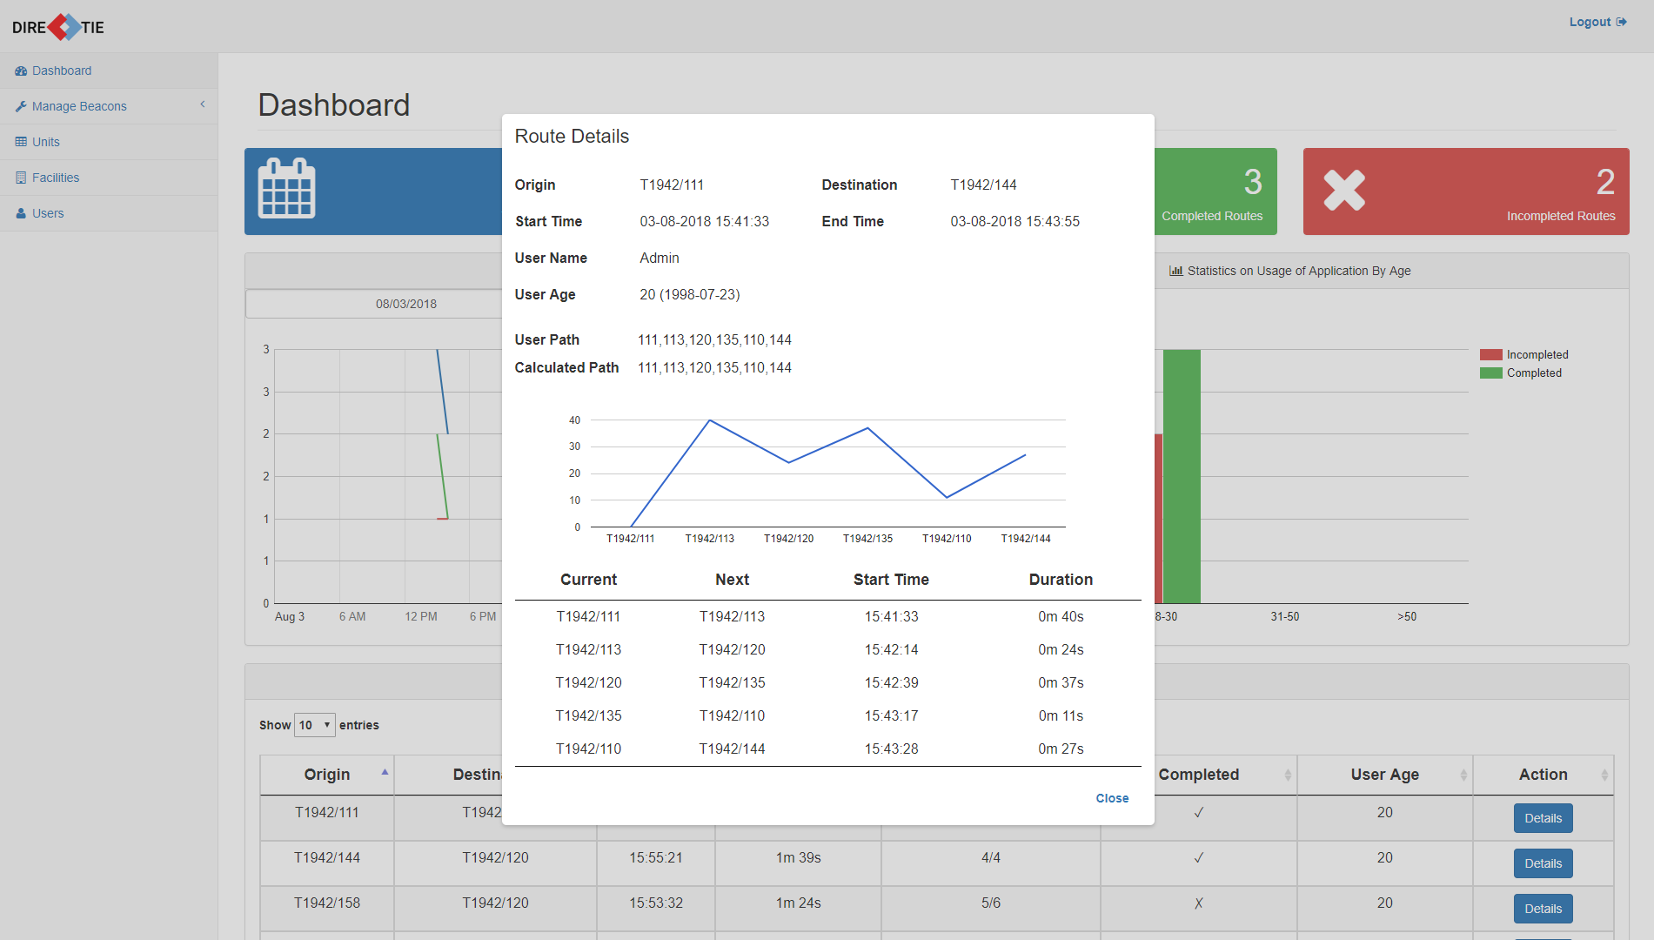

*Figure 6 Route Overview Table*

By clicking on the **“Details”** button under the “Action” column, you can view more information about a route as seen above in Figure 6. Details such as the time taken to travel from a beacon point to another beacon point can be seen. The graph and the table shows the time taken, and it can be compared easily. If the duration from a point to another point is not consistent, it may show that the user is taking a longer time to reach there.

### **3.0 Managing Beacons**

#### **3.1 View Beacons**

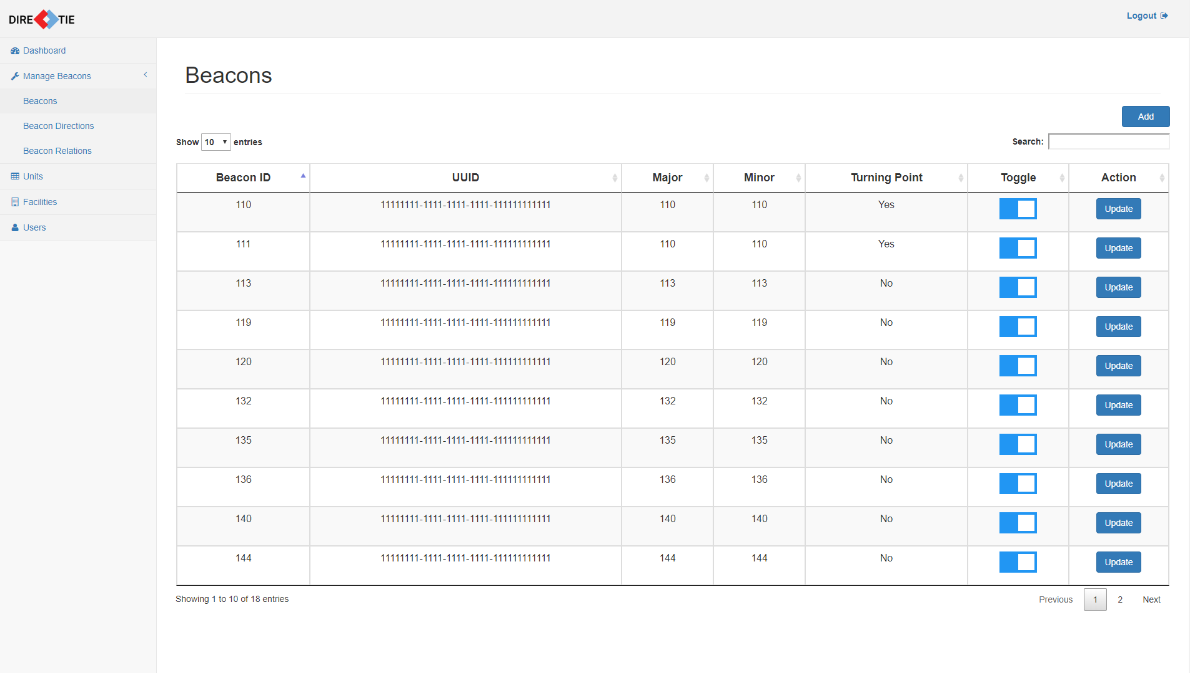

*Figure 7 Beacons Page*

To reach this page where you can view all the beacons, click on **“Beacons”** under the “Manage Beacons” category in the navigation menu.

You will be able to see the following information regarding all beacons

* ID
* UUID
* Major
* Minor
* Turning Point
* Beacon status (toggle active/inactive)

##### **3.1.1 Toggle Beacon Status**

To change a beacon’s status, click on the switch under “Toggle” to toggle in to be active or inactive.

#### **3.2 Adding a Beacon**

To add a beacon, click on the **“Add”** button that is located at the top right of the table of beacons.

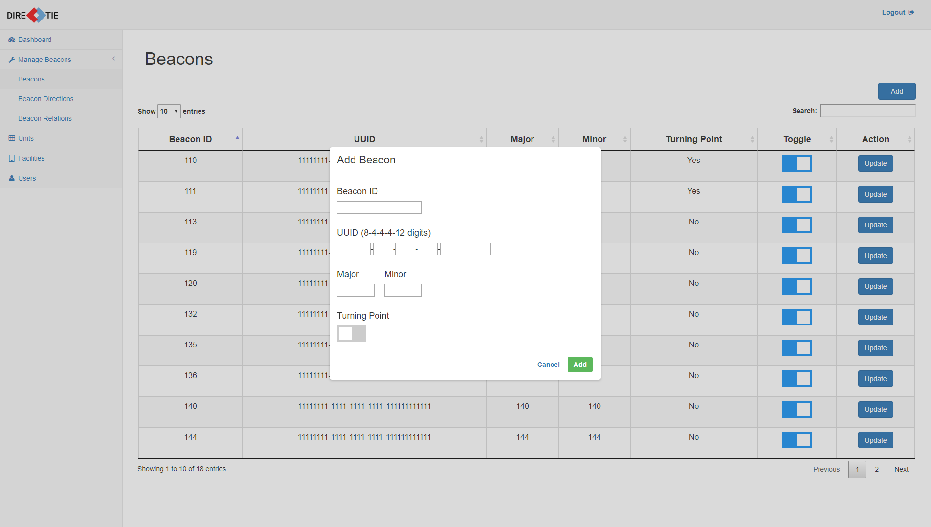

*Figure 8 Add beacon dialogue box*

Once it has been clicked, a dialogue box allowing you to enter the information necessary for a beacon will pop up as seen above in Figure 8.

You will be required to enter the following fields:

* Beacon ID
* UUID
* Major
* Minor
* Turning Point (by default, not a turning point)

Enter the details of the beacon and click on **“Add”** to save the details.

Click on **“Cancel”** to close the dialogue box without adding a new beacon.

#### 

#### **3.3 Updating a Beacon**

To update a beacon, click on the **“Update”** button respective to the beacon that you want to update which is located under the “Action” column of the table.

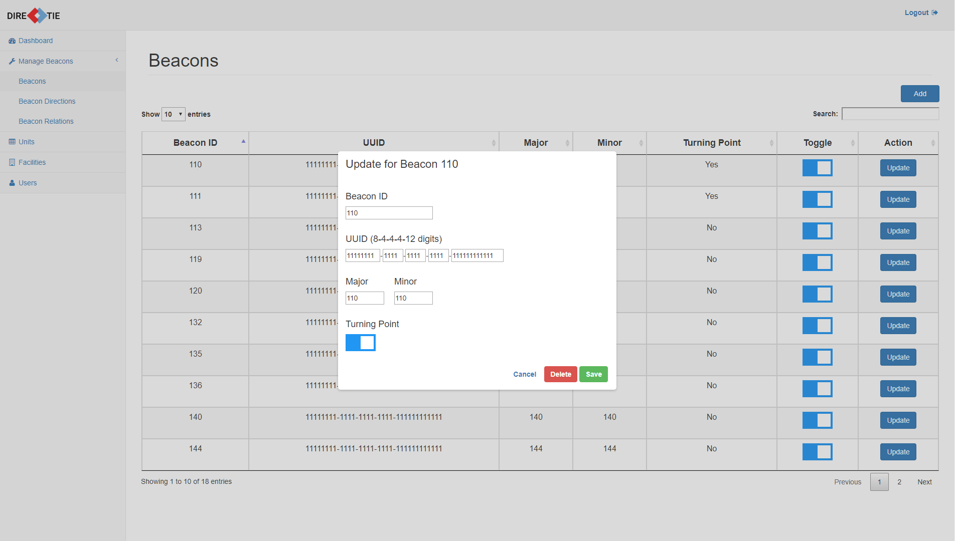

*Figure 9 Update beacon dialogue box*

Depending on which respective “Update” button you have clicked, the dialogue box that pops out will be filled with that specific beacon’s information.

You will be able to edit any of the following fields:

* Beacon ID
* UUID
* Major
* Minor
* Turning Point

Once you have finished editing, click on **“Save”** to save the details.

Click on **“Cancel”** to close the dialogue box without updating the beacon information.

#### **3.4 Deleting a Beacon**

To delete a beacon, click on the **“Delete”** button in the same dialogue box for updating a beacon.

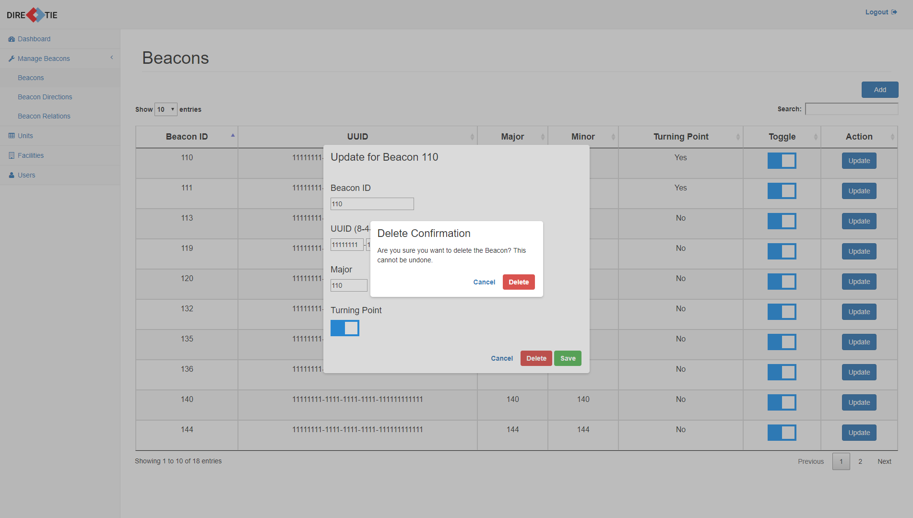

*Figure 10 Delete beacon confirmation box*

A confirmation box will pop up as seen above in Figure 10.

Click **“Delete”** to delete the beacon.

Click **“Cancel”** to close the confirmation box without deleting the beacon.

If “Delete” was clicked, a message will be shown to show that it has been deleted successfully.

### **4.0 Managing Beacon Directions**

#### **4.1 View Beacon Directions**

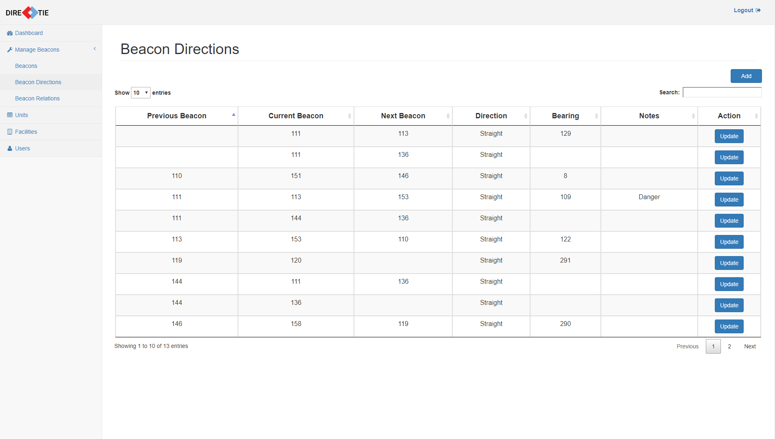

*Figure 11 Beacon Directions Page*

To reach this page where you can view all the beacon directions, click on **“Beacon Directions”** under the “Manage Beacons” category in the navigation menu.

You will be able to see the following information regarding all beacon directions

* Previous Beacon ID
* Current Beacon ID
* Next Beacon ID
* Direction
* Bearing
* Notes

#### **4.2 Adding a Beacon Direction**

To add a beacon direction, click on the **“Add”** button that is located at the top right of the table of beacon directions.

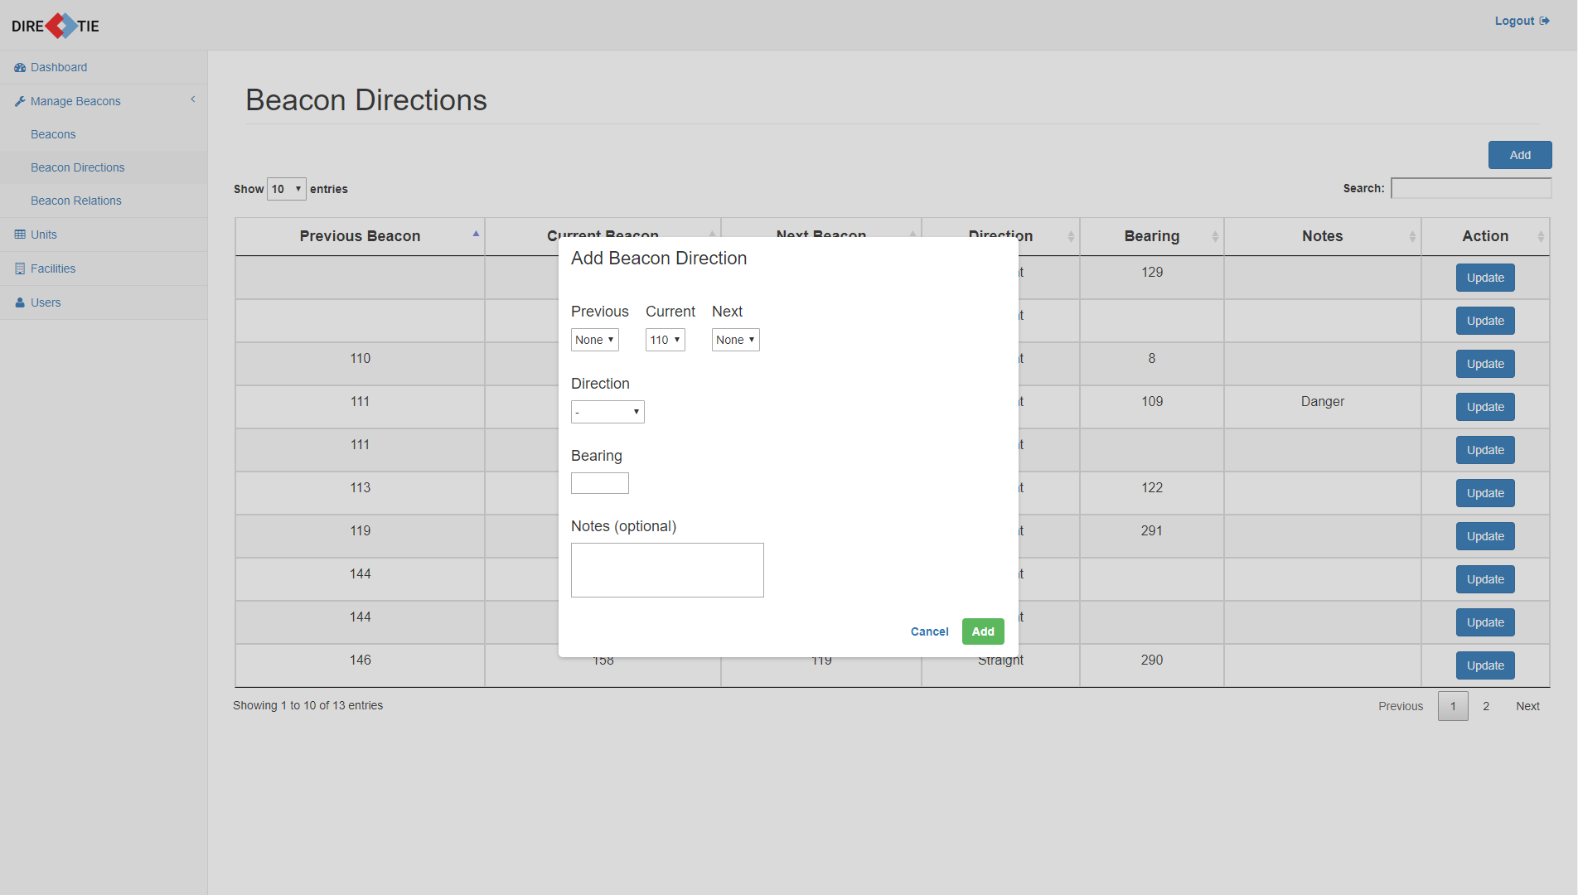

*Figure 12 Add beacon direction dialogue box*

Once it has been clicked, a dialogue box allowing you to enter the information necessary for a beacon direction will pop up as seen above in Figure 12.

You will be required to enter the following fields:

* Previous Beacon ID
* Current Beacon ID
* Next Beacon ID
* Direction
* Bearing
* Notes (optional)

Enter the details of the beacon direction and click on **“Add”** to save the details.

Click on **“Cancel”** to close the dialogue box without adding a new beacon direction.

#### 

#### **4.3 Updating a Beacon Direction**

To update a beacon direction, click on the **“Update”** button respective to the beacon direction that you want to update which is located under the “Action” column of the table.

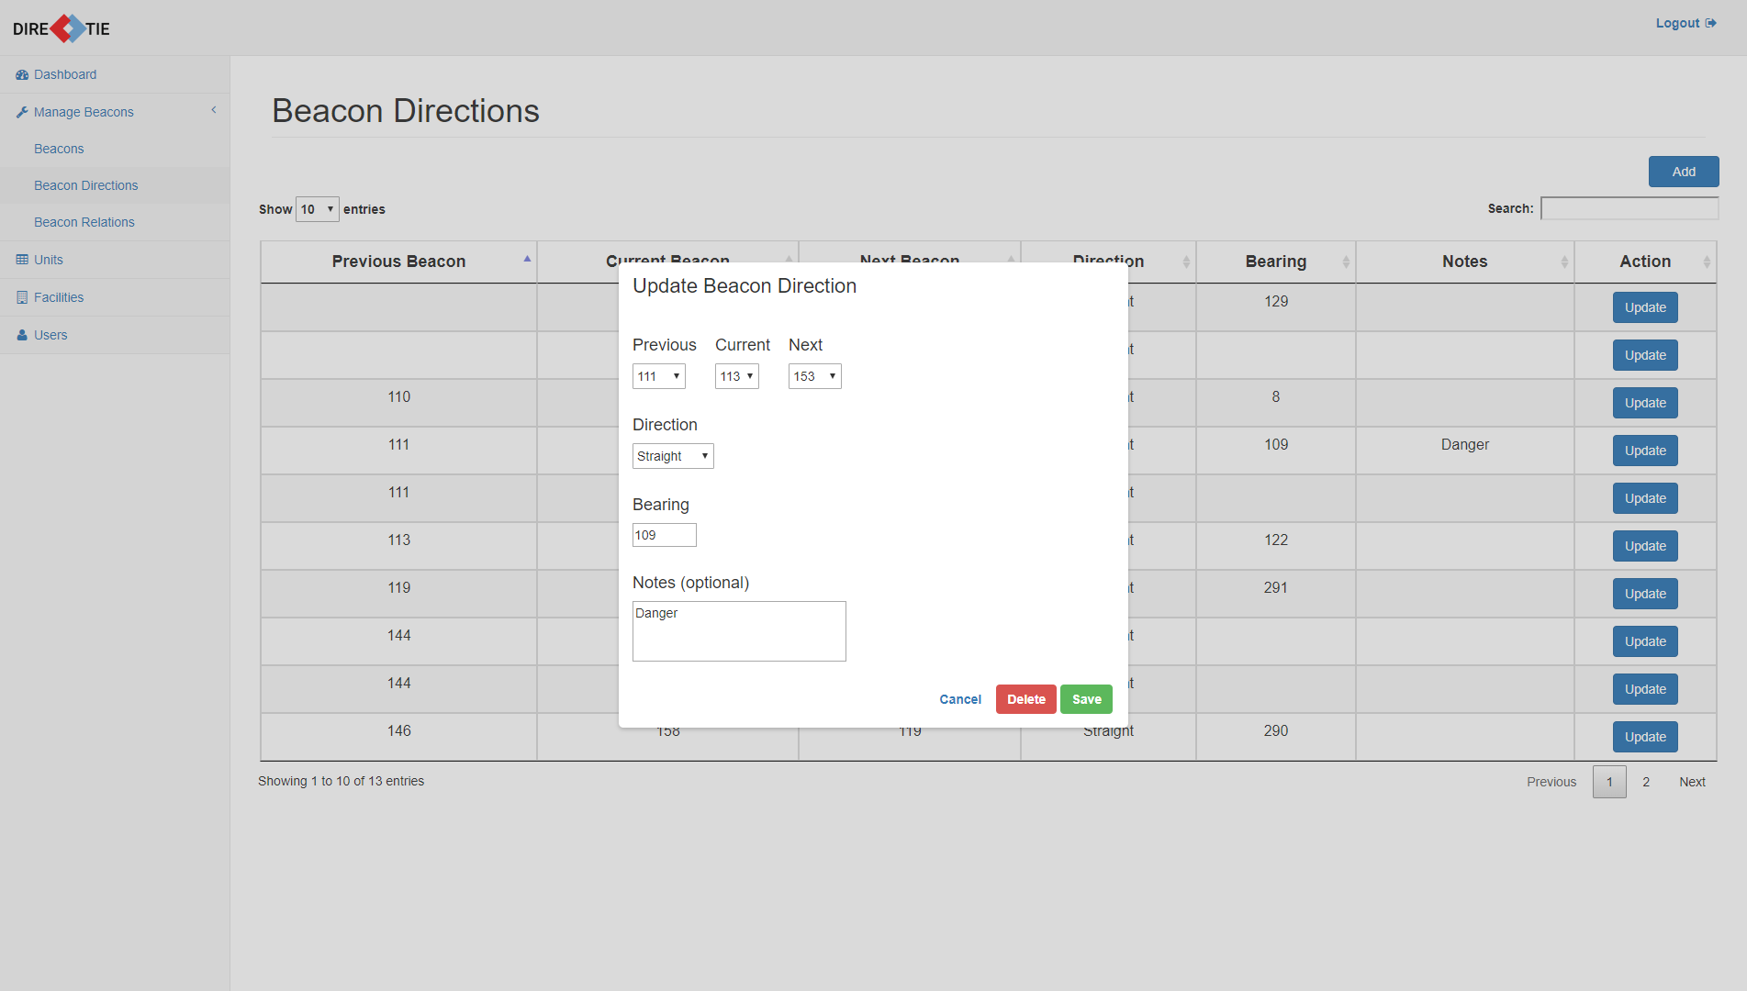

*Figure 13 Update beacon direction dialogue box*

Depending on which respective “Update” button you have clicked, the dialogue box that pops out will be filled with that specific beacon direction’s information.

You will be able to edit any of the following fields:

* Previous Beacon ID
* Current Beacon ID
* Next Beacon ID
* Direction
* Bearing
* Notes

Once you have finished editing, click on **“Save”** to save the details.

Click on **“Cancel”** to close the dialogue box without updating the beacon direction information.

#### **4.4 Deleting a Beacon Direction**

To delete a beacon direction, click on the **“Delete”** button in the same dialogue box for updating a beacon direction.



*Figure 14 Delete beacon direction confirmation box*

A confirmation box will pop up as seen above in Figure 14.

Click **“Delete”** to delete the beacon direction.

Click **“Cancel”** to close the confirmation box without deleting the beacon direction.

If “Delete” was clicked, a message will be shown to show that it has been deleted successfully.

### **5.0 Managing Beacon Relations**

#### **5.1 View Beacon Relations**

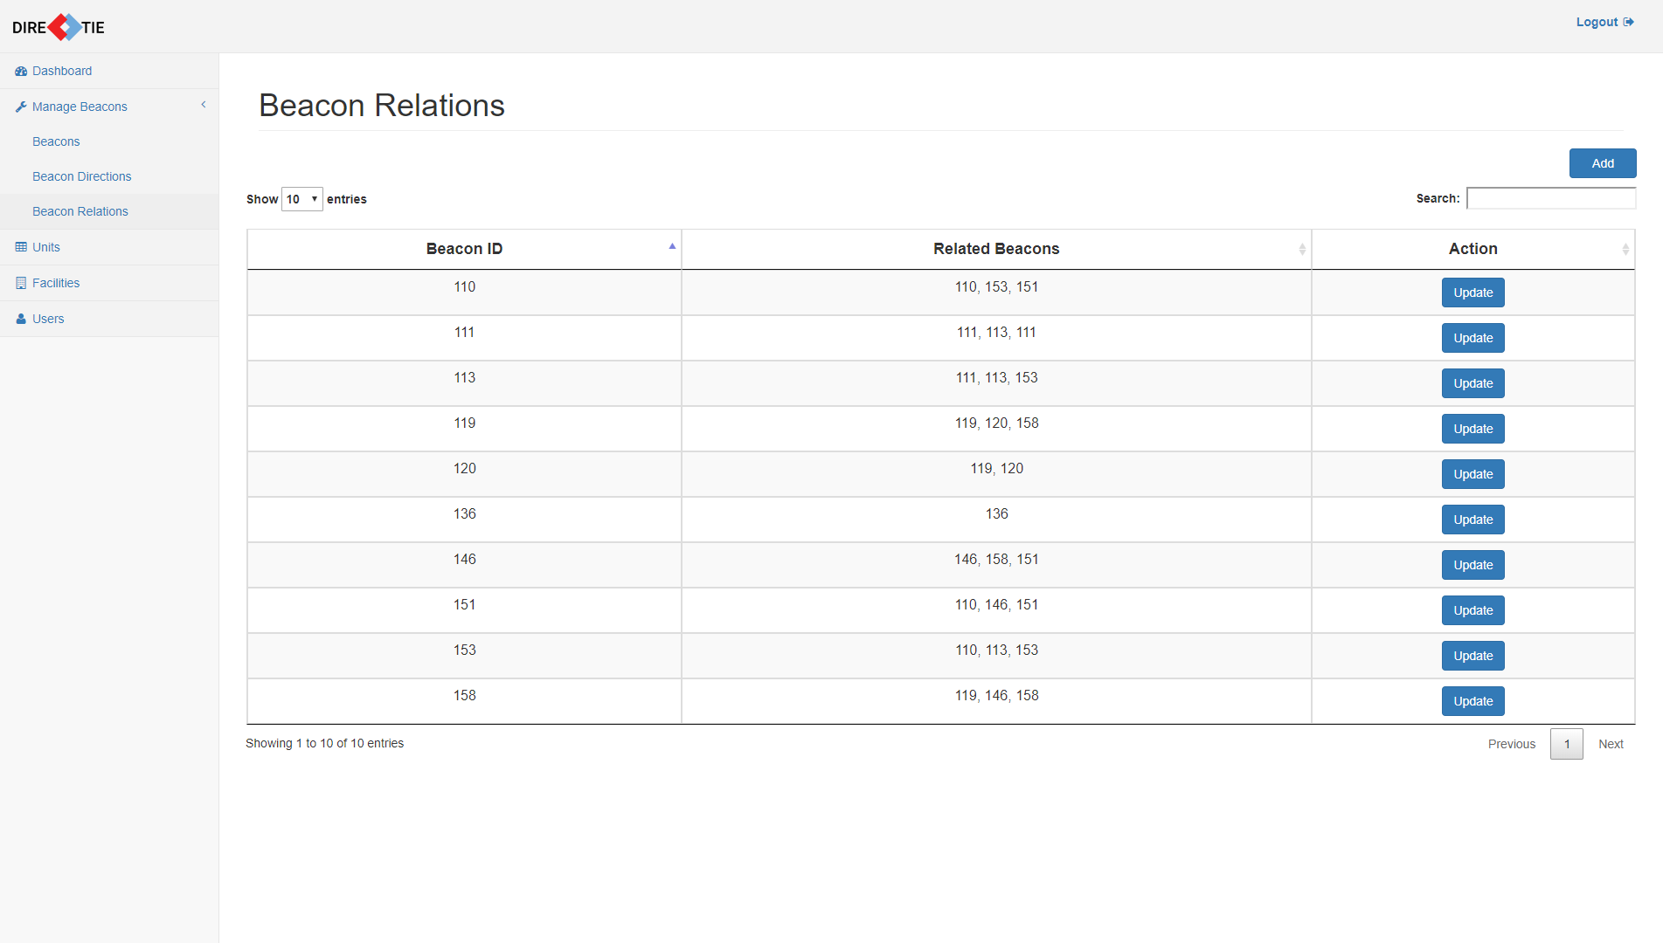

*Figure 15 Beacon Relations Page*

To reach this page where you can view all the beacon relations, click on **“Beacon Relations”** under the “Manage Beacons” category in the navigation menu.

You will be able to see the following information regarding all beacon relations

* BeaconID
* Related Beacons

#### **5.2 Adding a Beacon Relation**

To add a beacon relation, click on the **“Add”** button that is located at the top right of the table of beacon relations.

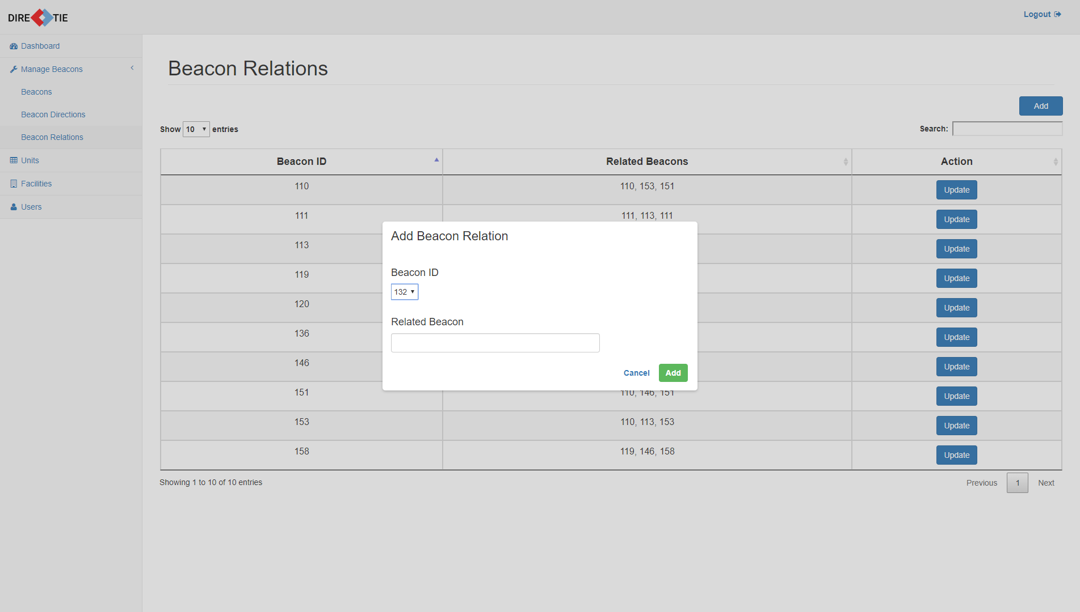

*Figure 16 Add beacon relation dialogue box*

Once it has been clicked, a dialogue box allowing you to enter the information necessary for a beacon relation will pop up as seen above in Figure 16.

You will be required to enter the following fields:

* Beacon ID
* Related Beacons

For the field “Related Beacons”, enter the ID of the beacon related to the beacon you want to add to.

For example, if a beacon with ID 1 has a related beacon with ID 2, enter “2” in the related beacon field. In the event that you want to add more related beacons to it, go ahead and enter another beacon ID in the same field.

Enter the details of the beacon relation and click on **“Add”** to save the details.

Click on **“Cancel”** to close the dialogue box without adding a new beacon relation.

#### **5.3 Updating a Beacon Relation**

To update a beacon relation, click on the **“Update”** button respective to the beacon relation that you want to update which is located under the “Action” column of the table.

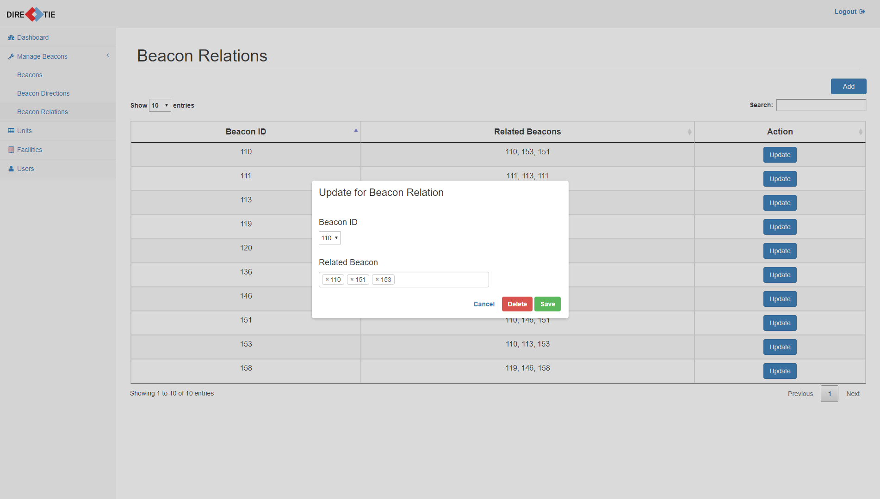

*Figure 17 Update beacon relation dialogue box*

Depending on which respective “Update” button you have clicked, the dialogue box that pops out will be filled with that specific beacon relation’s information.

You will be able to edit any of the following fields:

* Beacon ID
* Related Beacons

To remove a related beacon from this relation, click on the “x” beside the tag of the related beacon ID.

Once you have finished editing, click on **“Save”** to save the details.

Click on **“Cancel”** to close the dialogue box without updating the beacon relation information.

#### **5.4 Deleting a Beacon Relation**

To delete a beacon relation, click on the **“Delete”** button in the same dialogue box for updating a beacon relation.

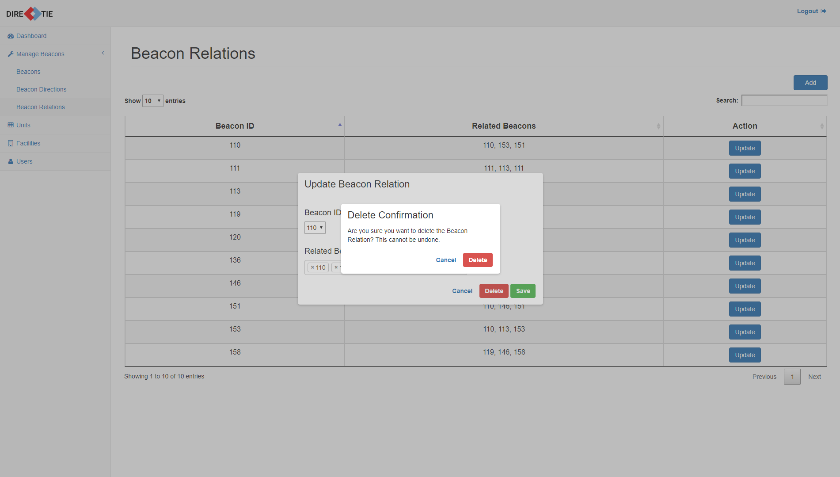

*Figure 18 Delete beacon relation confirmation box*

A confirmation box will pop up as seen above in Figure 18.

Click **“Delete”** to delete the beacon relation.

Click **“Cancel”** to close the confirmation box without deleting the beacon relation.

If “Delete” was clicked, a message will be shown to show that it has been deleted successfully.

### **6.0 Managing Units**

#### **6.1 View Units**

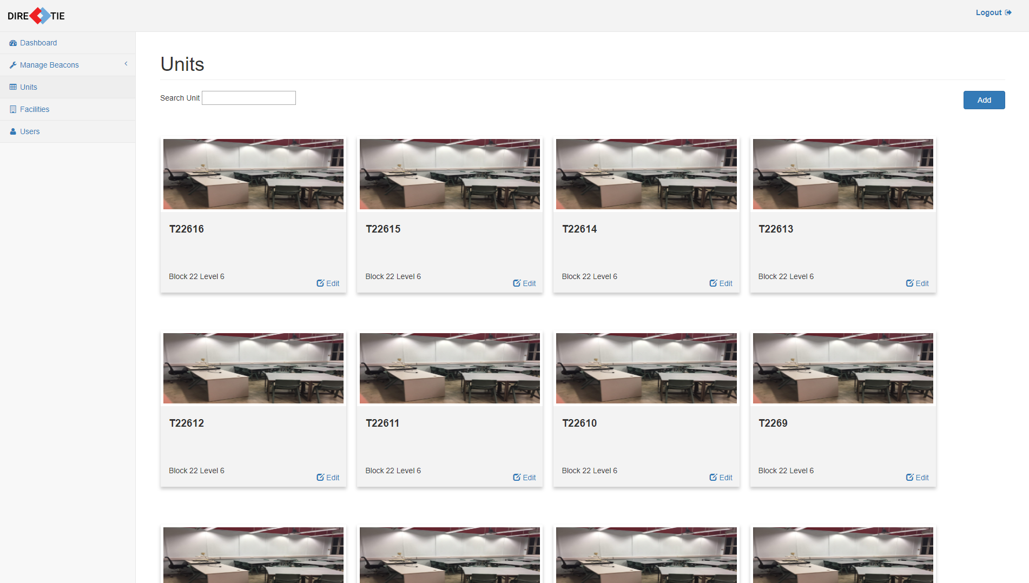

*Figure 19 Units Page*

To reach this page where you can view all the units, click on **“Units”** in the navigation menu.

You will be able to see the following information regarding all units

* Unit Image
* Unit No.
* Block
* Level

#### **6.2 Adding a Unit**

To add a unit, click on the **“Add”** button that is located at the top right of the page.

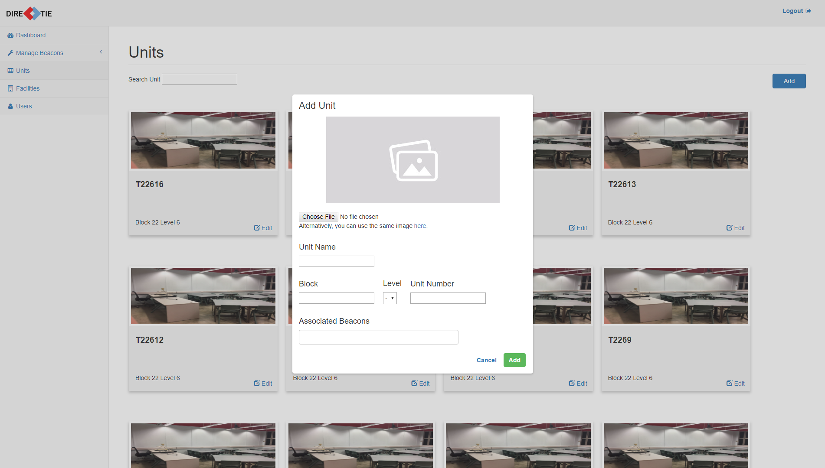

*Figure 20 Add unit dialogue box*

Once it has been clicked, a dialogue box allowing you to enter the information necessary for a unit will pop up as seen above in Figure 20.

You will be required to enter the following fields:

* Image
* Unit Name
* Block
* Level
* Unit No.
* Associated Beacons within this unit

For the image required for the unit, click on **“Choose File”** to select an image from from your computer.

Enter the details of the unit and click on **“Add”** to save the details.

Click on **“Cancel”** to close the dialogue box without adding a new unit.

#### **6.3 Updating a Unit**

To update a unit, click on the **“Update”** button respective to the unit card that you want to update.

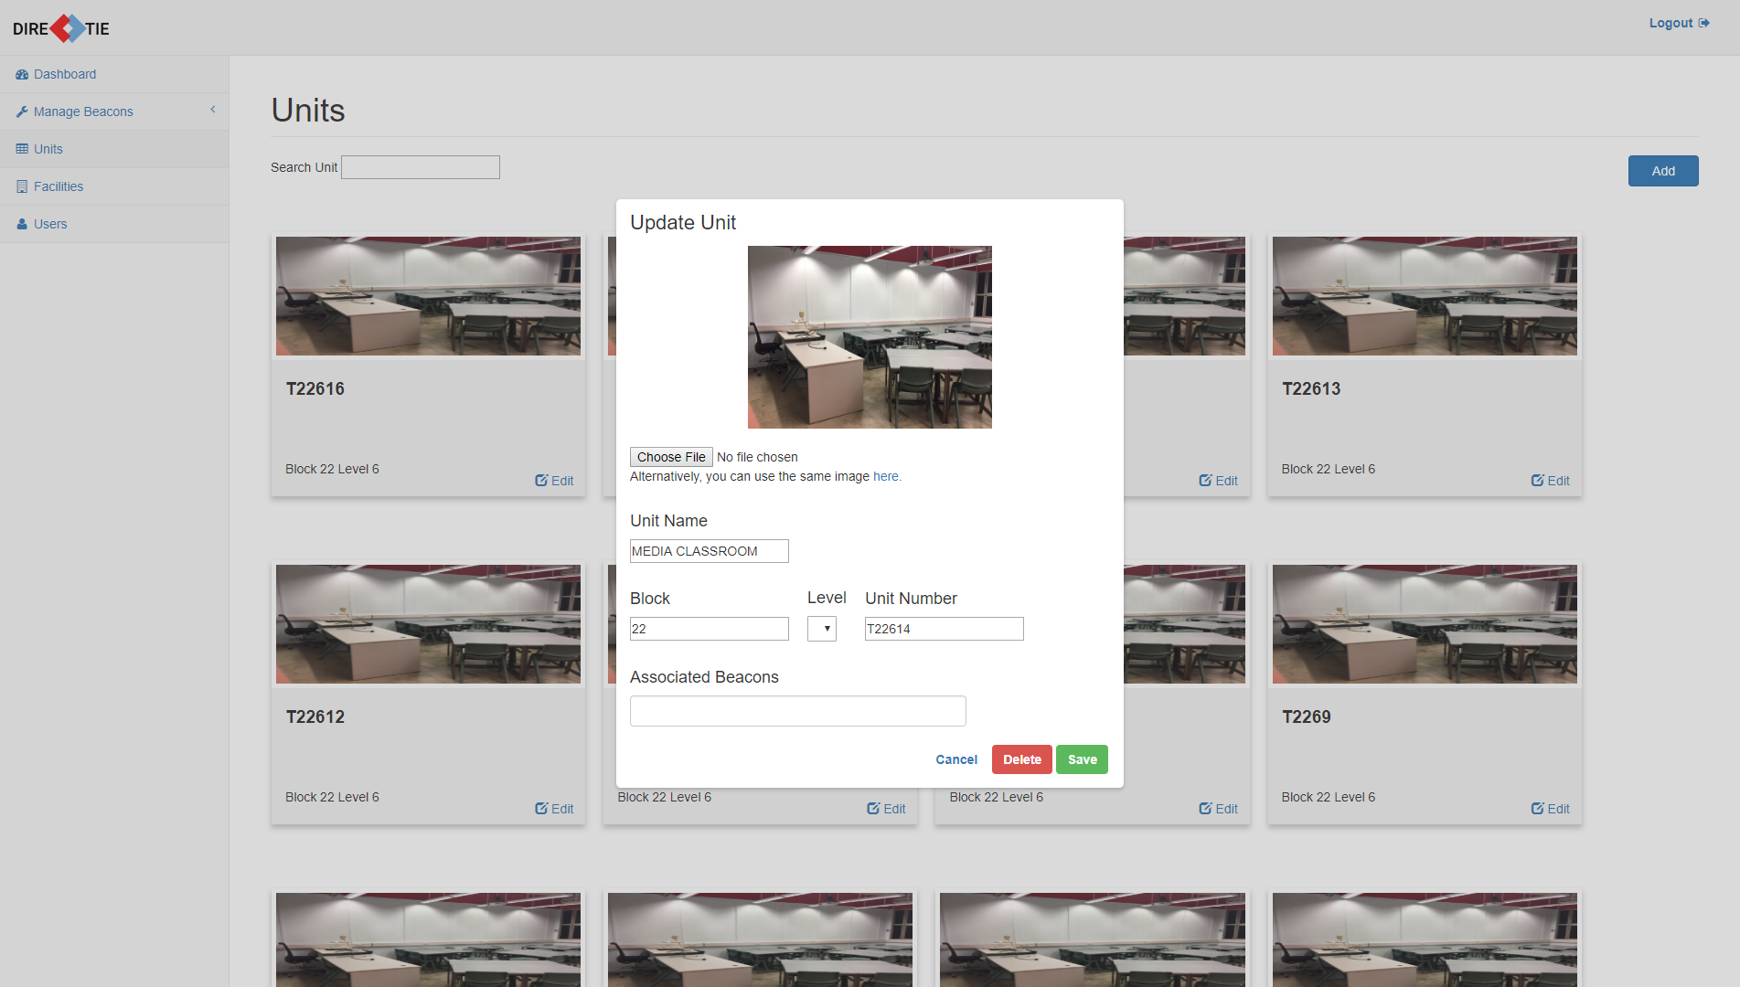

*Figure 21 Update unit dialogue box*

Depending on which respective “Update” button you have clicked, the dialogue box that pops out will be filled with that specific unit’s information.

You will be able to edit any of the following fields:

* Image
* Unit Name
* Block
* Level
* Unit No.
* Associated Beacons within this unit

Once you have finished editing, click on **“Save”** to save the details.

Click on **“Cancel”** to close the dialogue box without updating the unit information.

#### 

#### **6.4 Deleting a Unit**

To delete a unit, click on the **“Delete”** button in the same dialogue box for updating a unit.

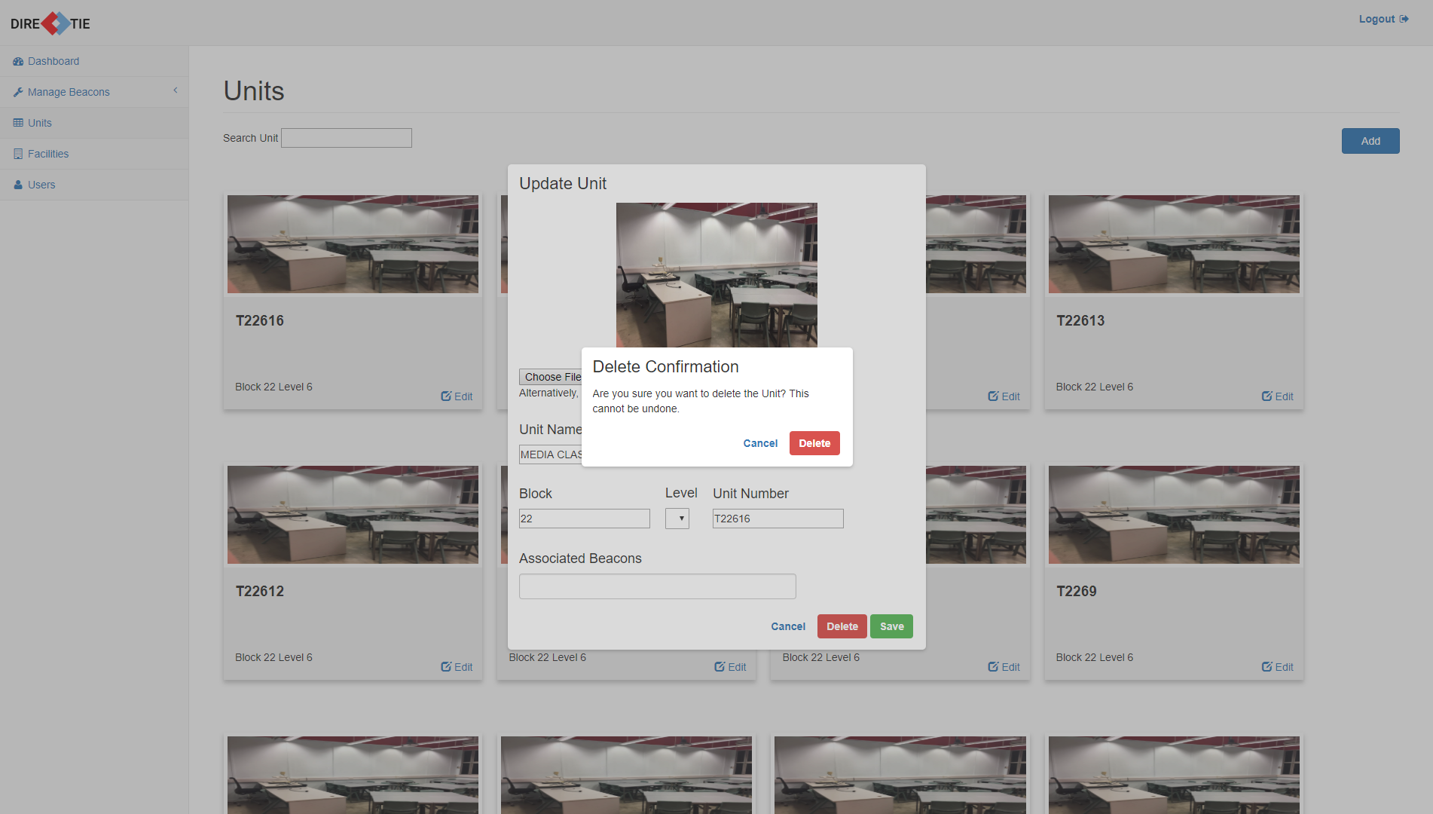

*Figure 22 Delete unit confirmation box*

A confirmation box will pop up as seen above in Figure 22.

Click **“Delete”** to delete the unit.

Click **“Cancel”** to close the confirmation box without deleting the unit.

If “Delete” was clicked, a message will be shown to show that it has been deleted successfully.

### **7.0 Managing Facilities**

#### **7.1 View Facilities**

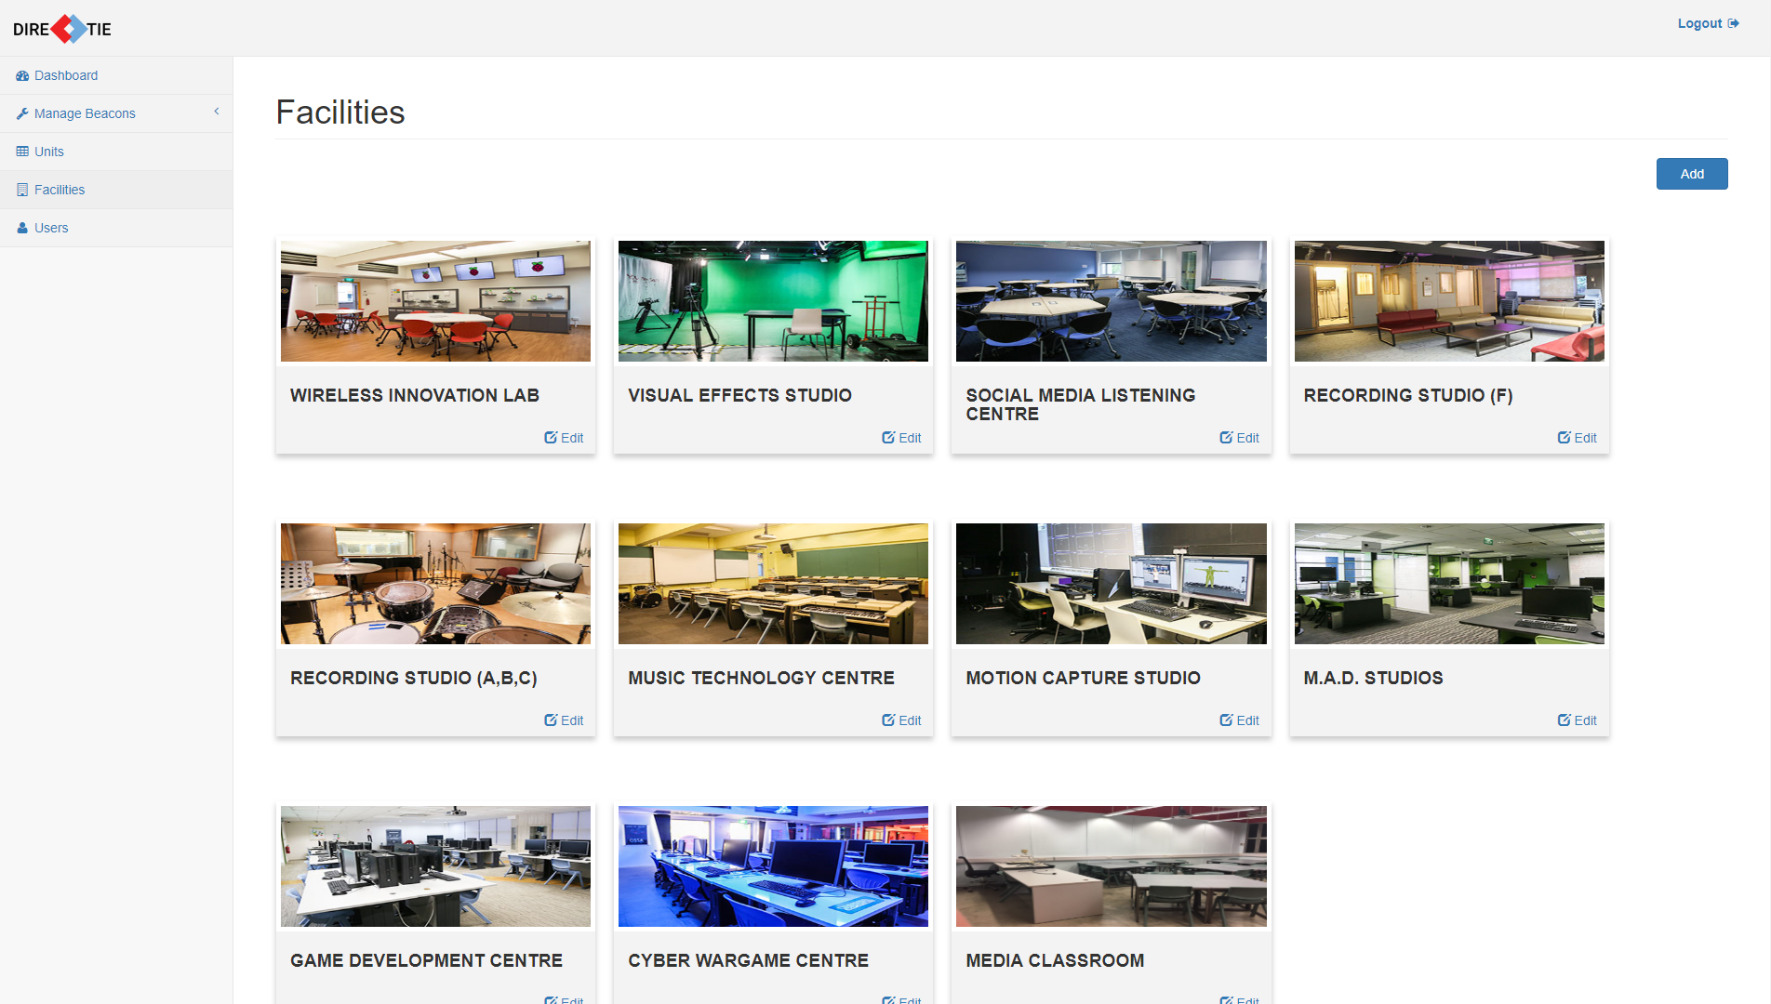

*Figure 23 Facilities Page*

To reach this page where you can view all the facilities, click on **“Facilities”** in the navigation menu.

You will be able to see the following information regarding all facilities

* Facility Image
* Facility Name

#### **7.2 Adding a Facility**

To add a facility, click on the **“Add”** button that is located at the top right of the page.

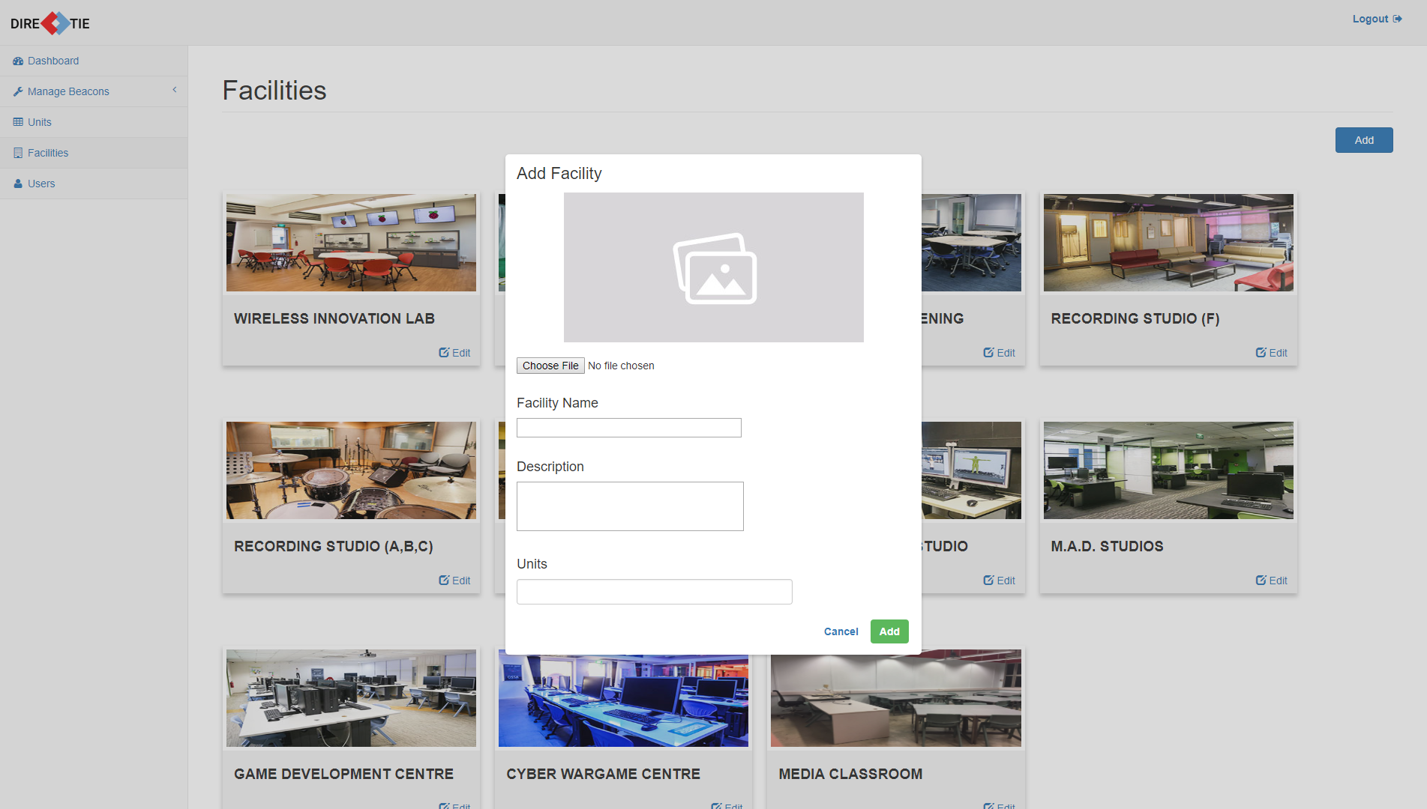

*Figure 24 Add facility dialogue box*

Once it has been clicked, a dialogue box allowing you to enter the information necessary for a facility will pop up as seen above in Figure 24.

You will be required to enter the following fields:

* Facility Image
* Facility Name
* Description
* Units associated with this facility (if available)

For the image required for the facility, click on **“Choose File”** to select a suitable image from your computer.

Enter the details of the facility and click on **“Add”** to save the details.

Click on **“Cancel”** to close the dialogue box without adding a new facility.

#### 

#### **7.3 Updating a Facility**

To update a facility, click on the **“Update”** button respective to the facility card that you want to update.

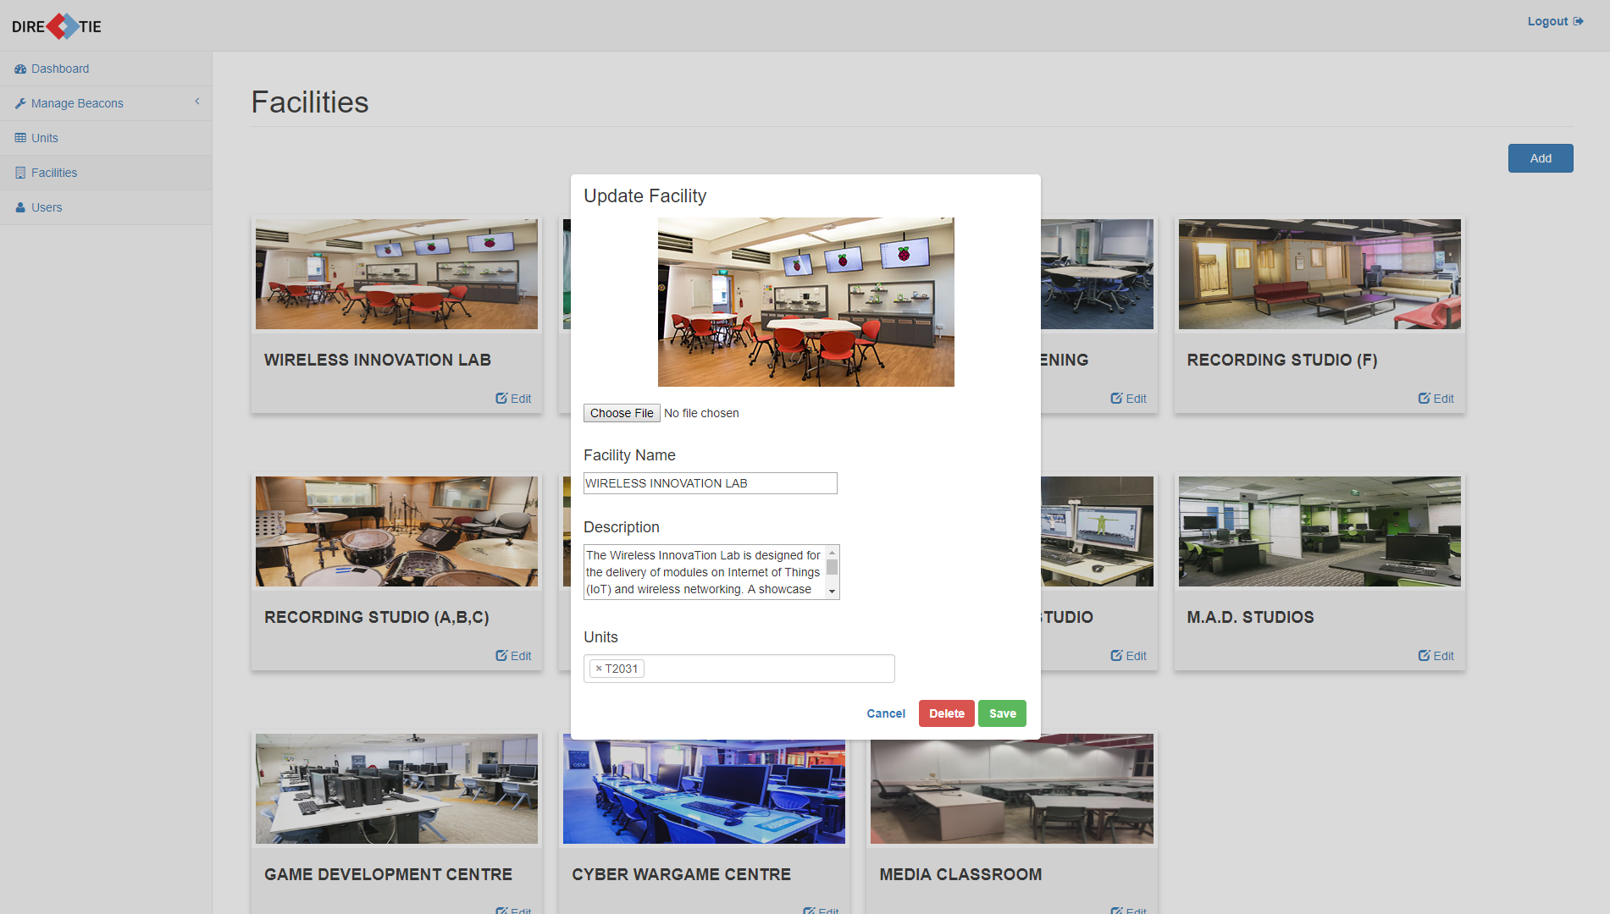

*Figure 25 Update facility dialogue box*

Depending on which respective “Update” button you have clicked, the dialogue box that pops out will be filled with that specific facility’s information.

You will be able to edit any of the following fields:

* Facility Image
* Facility Name
* Description
* Units associated with this facility (if available)

Once you have finished editing, click on **“Save”** to save the details.

Click on **“Cancel”** to close the dialogue box without updating the facility information.

#### 

#### **7.4 Deleting a Facility**

To delete a facility, click on the **“Delete”** button in the same dialogue box for updating a facility.

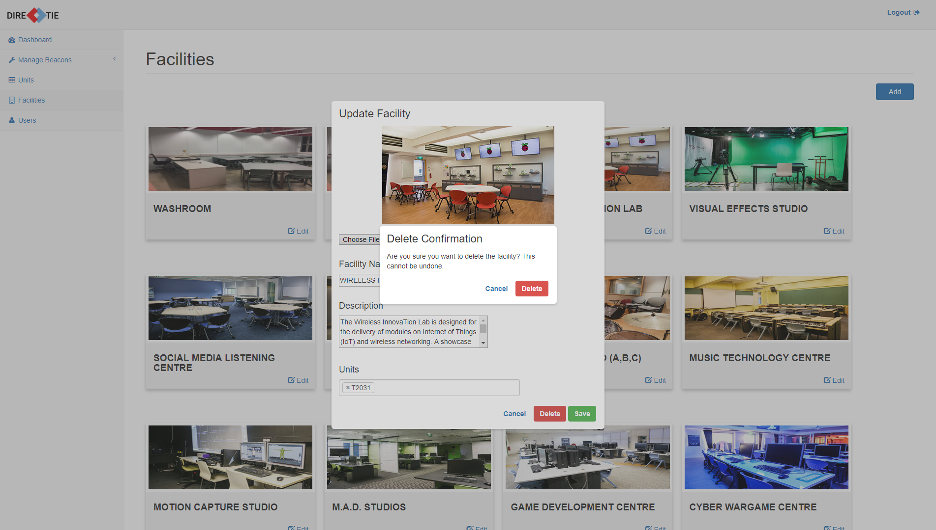

*Figure 26 Delete facility confirmation box*

A confirmation box will pop up as seen above in Figure 26.

Click **“Delete”** to delete the facility.

Click **“Cancel”** to close the confirmation box without deleting the facility.

If “Delete” was clicked, a message will be shown to show that it has been deleted successfully.

### **8.0 Managing Users**

#### **8.1 View Users**

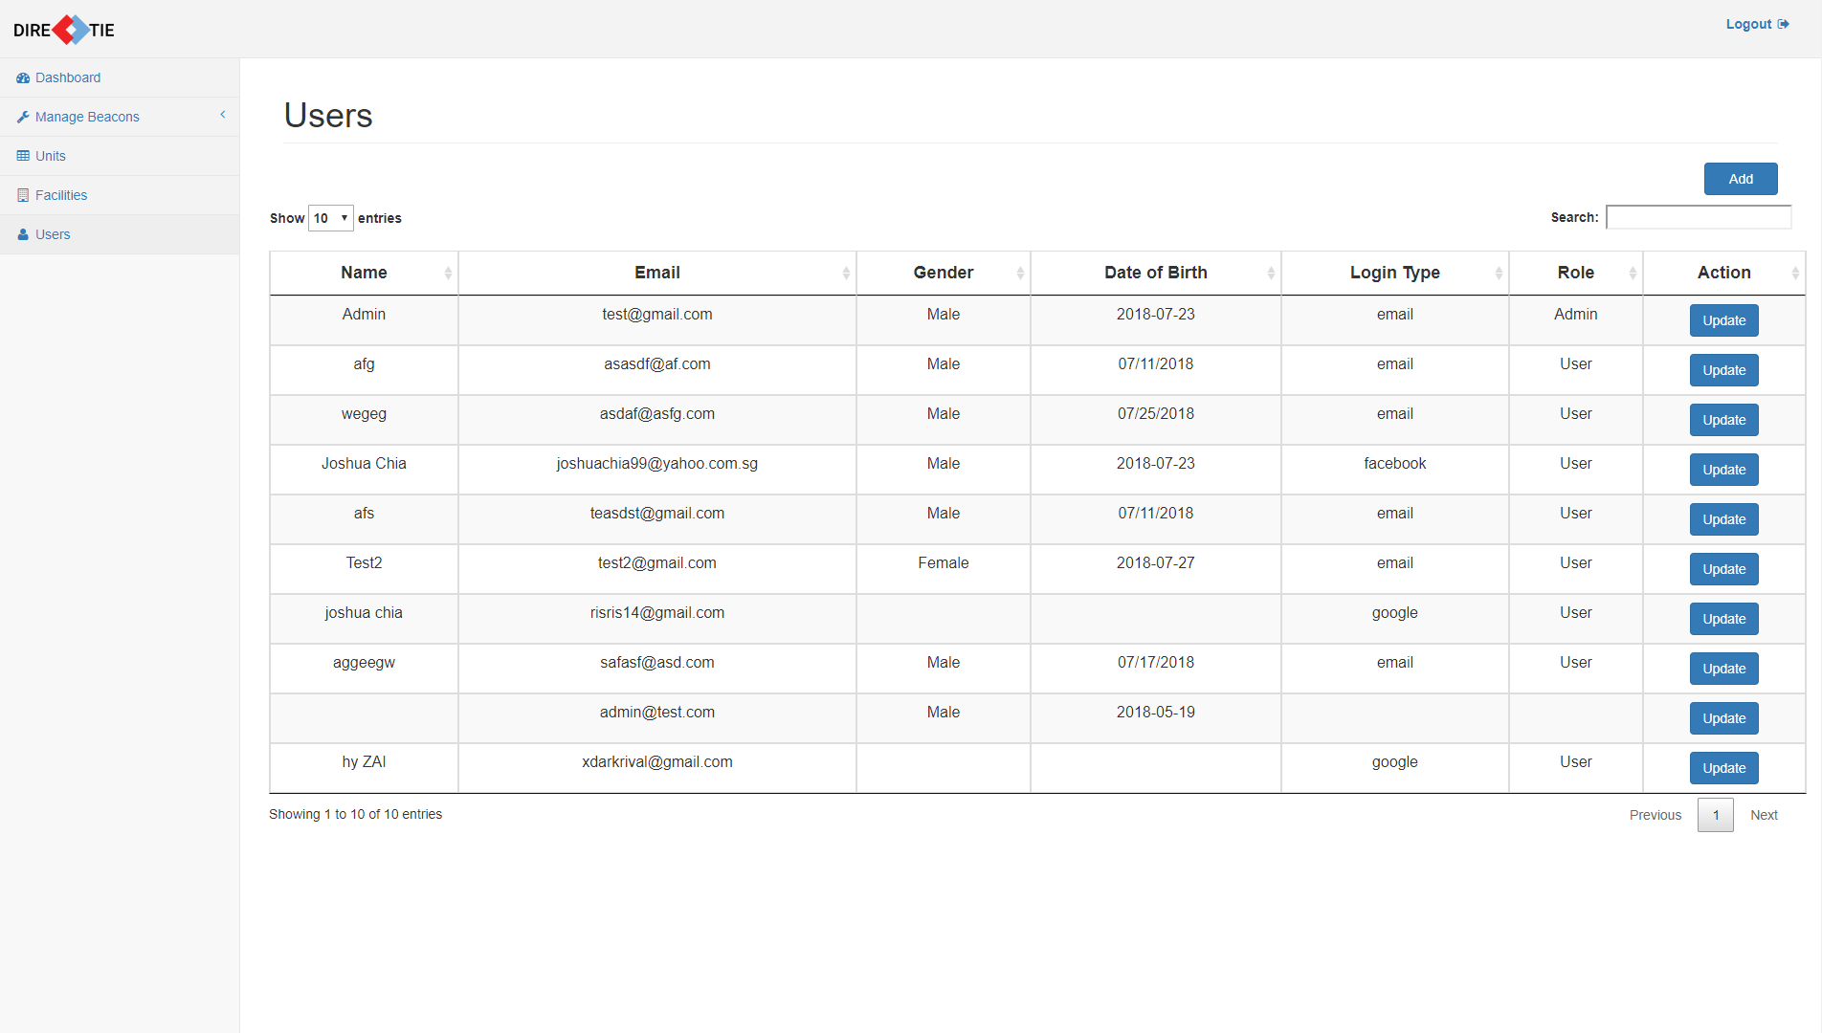

*Figure 27 Users Page*

To reach this page where you can view all the users, click on **“Users”** in the navigation menu.

You will be able to see the following information regarding all users

* Name
* Email
* Gender
* Date of Birth
* Login Type
* Role

#### **8.2 Adding a User**

To add a user, click on the **“Add”** button that is located at the top right of the page.

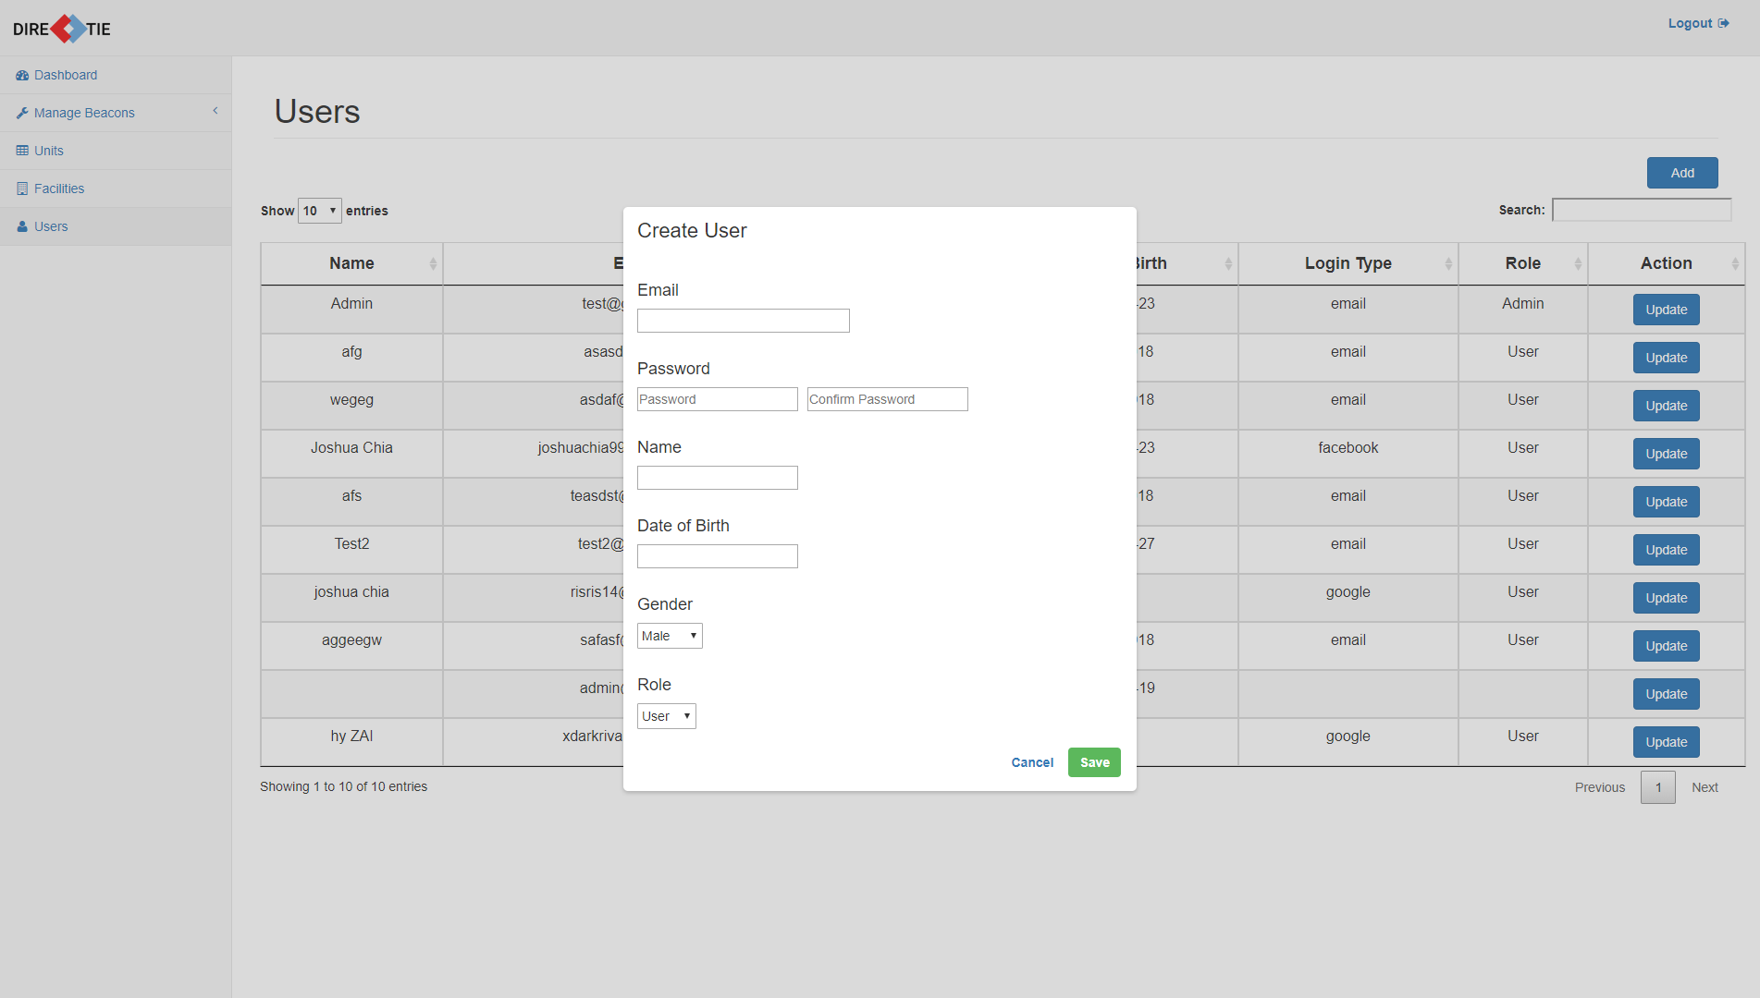

*Figure 28 Add user dialogue box*

Once it has been clicked, a dialogue box allowing you to enter the information necessary for a user will pop up as seen above in Figure 28.

You will be required to enter the following fields:

* Email
* Password
* Name
* Date of Birth
* Gender
* Role

Enter the details of the user and click on **“Add”** to save the details.

Click on **“Cancel”** to close the dialogue box without adding a new user.

#### 

#### **8.3 Updating a User**

To update a user’s role, click on the **“Update”** button respective to the user that you want to update.

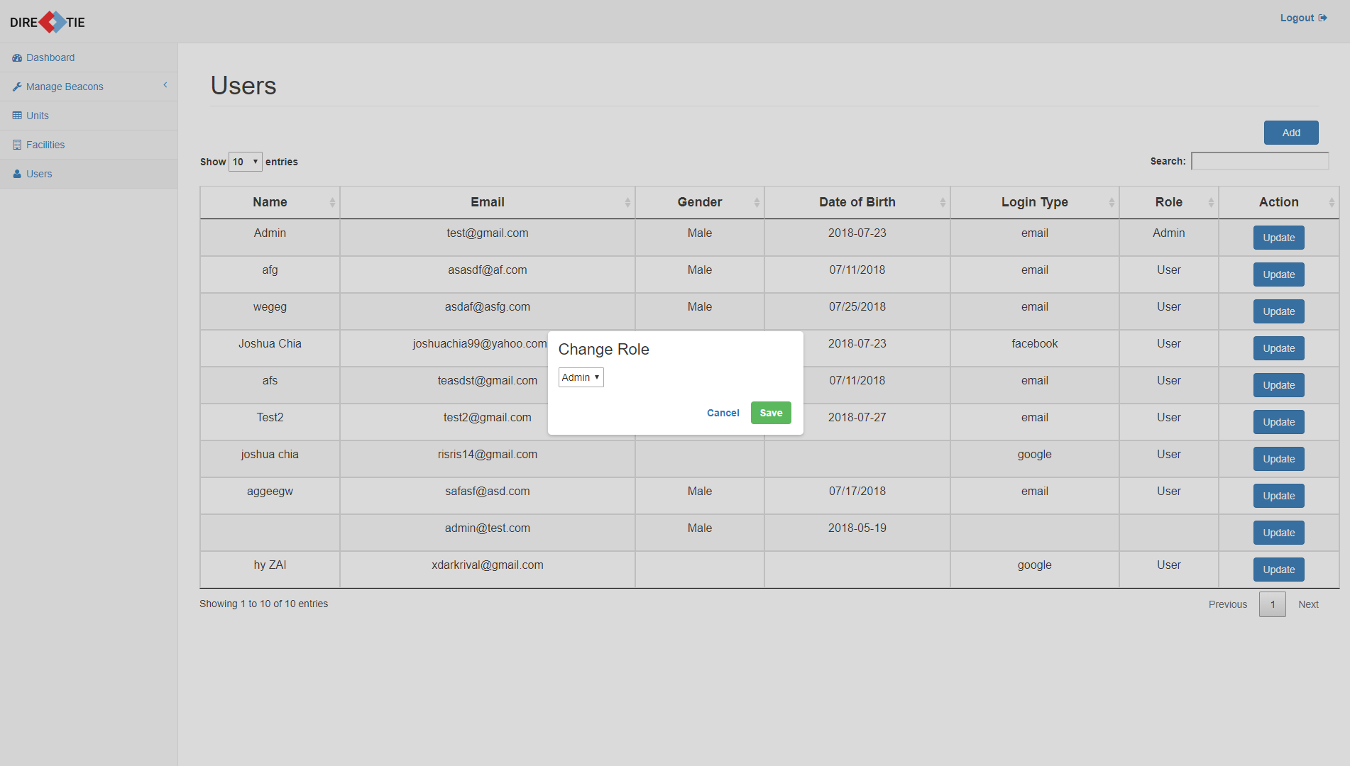

*Figure 29 Update user dialogue box*

Depending on which respective “Update” button you have clicked, the dialogue box that pops out will be filled with that specific user’s current role.

You will only be able to edit the following field:

* Role

Once you have finished editing, click on **“Save”** to save the details.

Click on **“Cancel”** to close the dialogue box without updating the user role.